Presentation title
Title, 14 pt, Bold
Font, Times New Roman
Authors
& Affiliation,
12 pt
First Middle Last¹, First Middle Last¹, First Middle Last^{1,2}, First Middle Last¹
¹Affiliation, City, Country
² Affiliation, City, Country
E-mail, 12 pt, Italic
E-mail: XXXXX@XXXXXXXXXXXXXX

This symposium will provide an international forum for discussions on advanced atomic force microscopy (AFM) and related techniques for liquid-environment applications. The techniques include high-speed AFM^{[1]}, atomic-resolution AFM^{[2]} and SICM^{[3]} while the applications include nanoscale or subnanoscale studies on biomolecules, cells, bioengineering materials, crystal growth, self-assembly and electrochemical reactions.
Main
Text,
12 pt
This symposium will be organized as a part of the activities in Bio-AFM Frontier Research Center, Kanazawa University. Through this symposium, we aim to expand our international collaboration network as well as to advance our understanding on the instrumentation and applications of in-liquid scanning probe techniques.
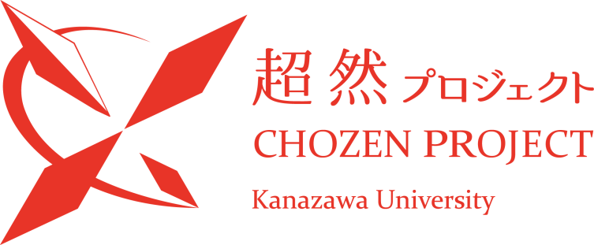
Figure
Caption,
11 pt
Figure 1 Logo of CHOZEN project. CHOZEN project is run by researchers in Kanazawa University conducting distinctive researches with high advantages. The project aims at the formation of worldwide research hubs.

References
11 pt
- T. Ando, T. Uchihashi & S. Scheuring, Filming Biomolecular processes by high-speed atomic force microscopy. Chem. Rev. 114, 3120−3188 (2014).
- T. Fukuma, Y. Ueda, S. Yoshioka, & H. Asakawa, Atomic-Scale Distribution of Water Molecules at the Mica-Water Interface Visualized by Three-Dimensional Scanning Force Microscopy. Phys. Rev. Lett. 104, 016101 (2010).
- P. Novak et al., Nanoscale live cell imaging using hopping probe ion conductance microscopy. Nat. Methods 6, 279-281 (2009).
References, 11 pt

